Orfiactive step by step guide

Adults

1. Download the orfiactive app on the app store link will be provided

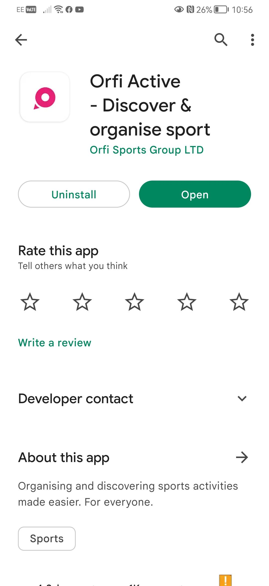

1. Make an account follow on screen instructions make sure to verify the account via email

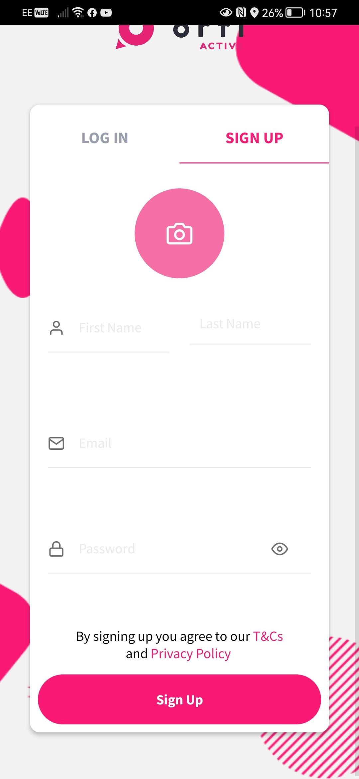

1. Once account has been made please use link to join the warrington volleyball group
2. To view sessions go to myactive and click on the warrington volleyball club group, then click on view group calendar

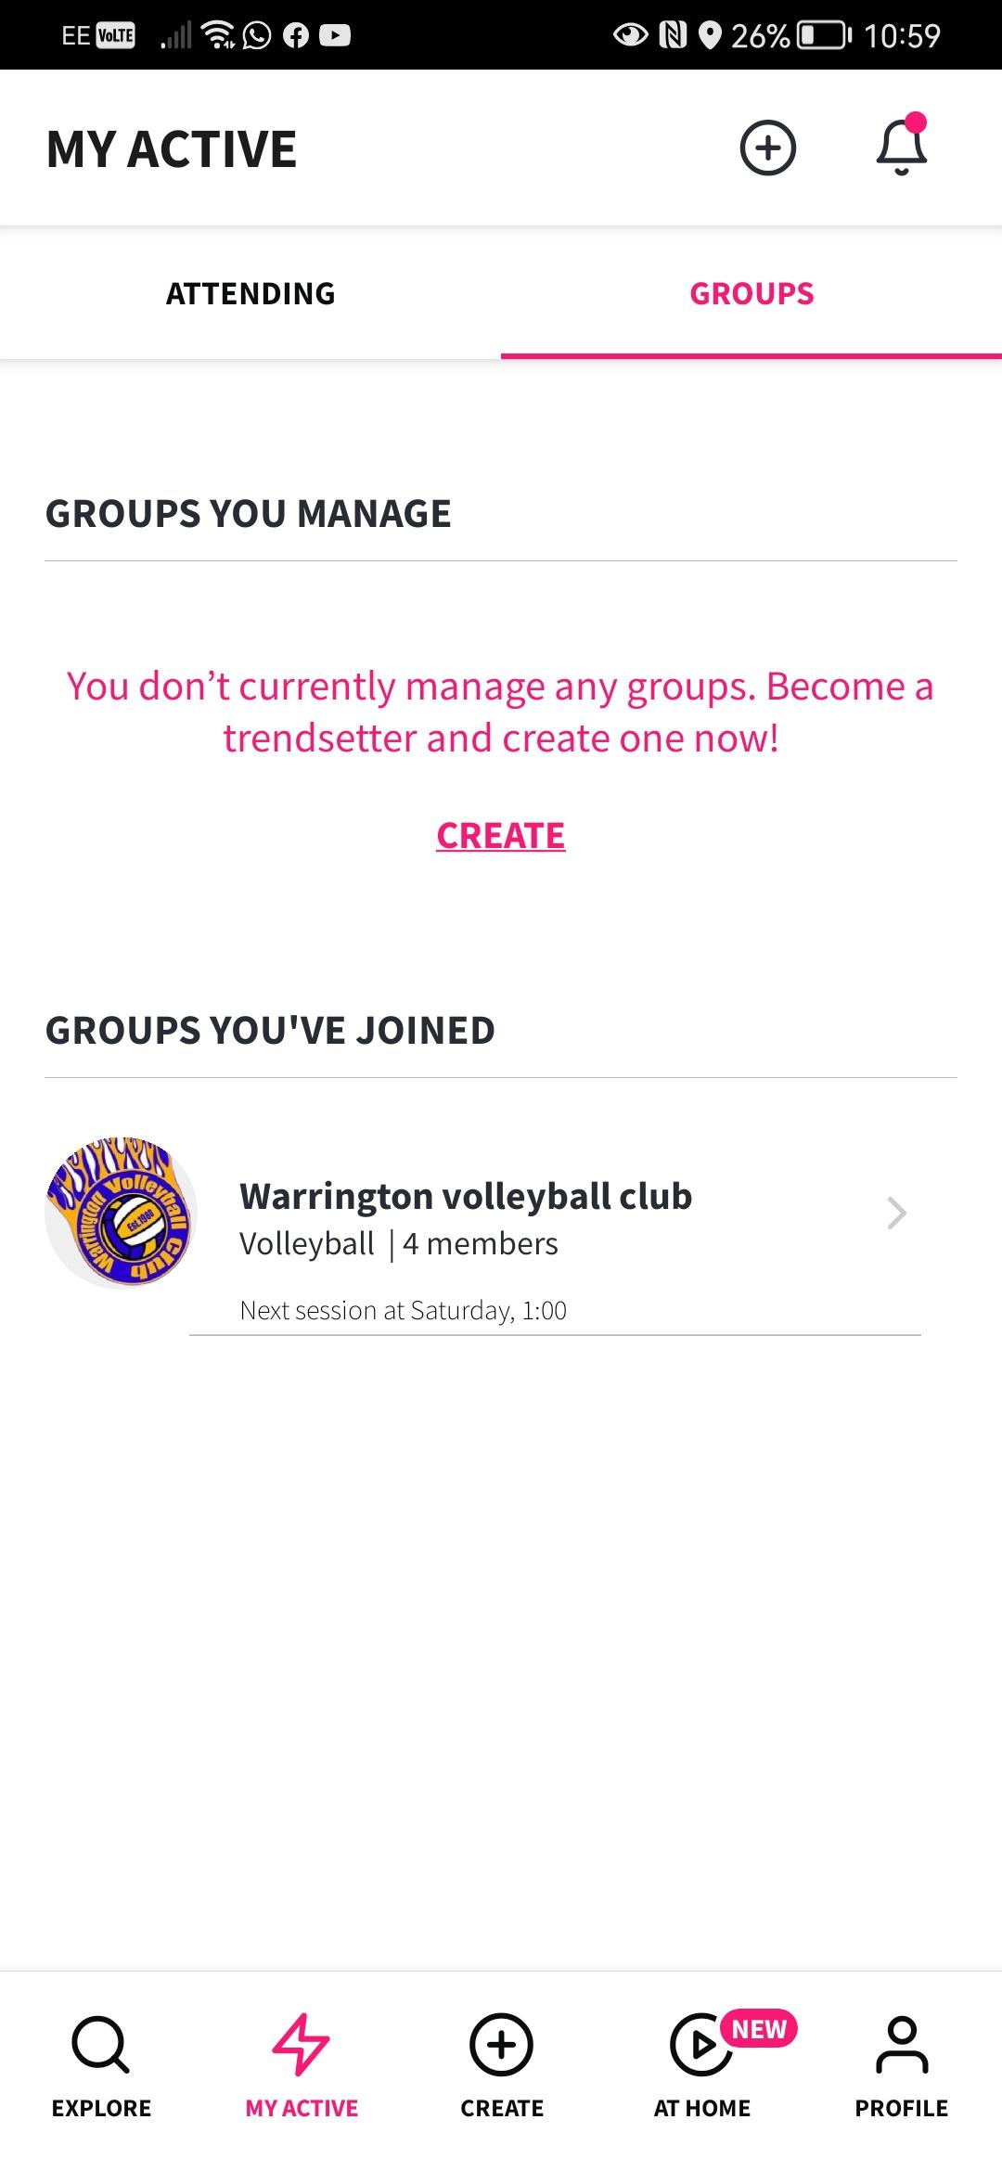>

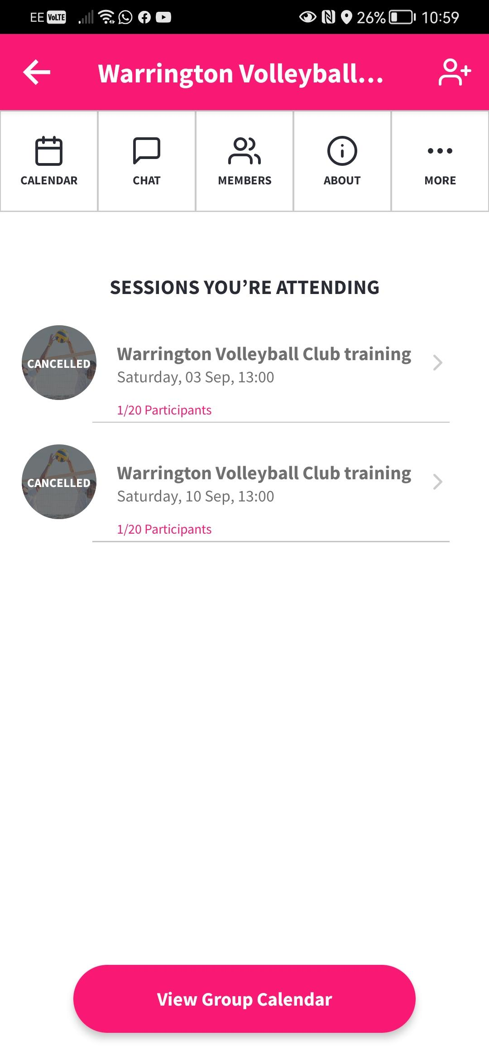

1. To join a session clicked on desired session by finding the correct date and press join session and select correct payment method

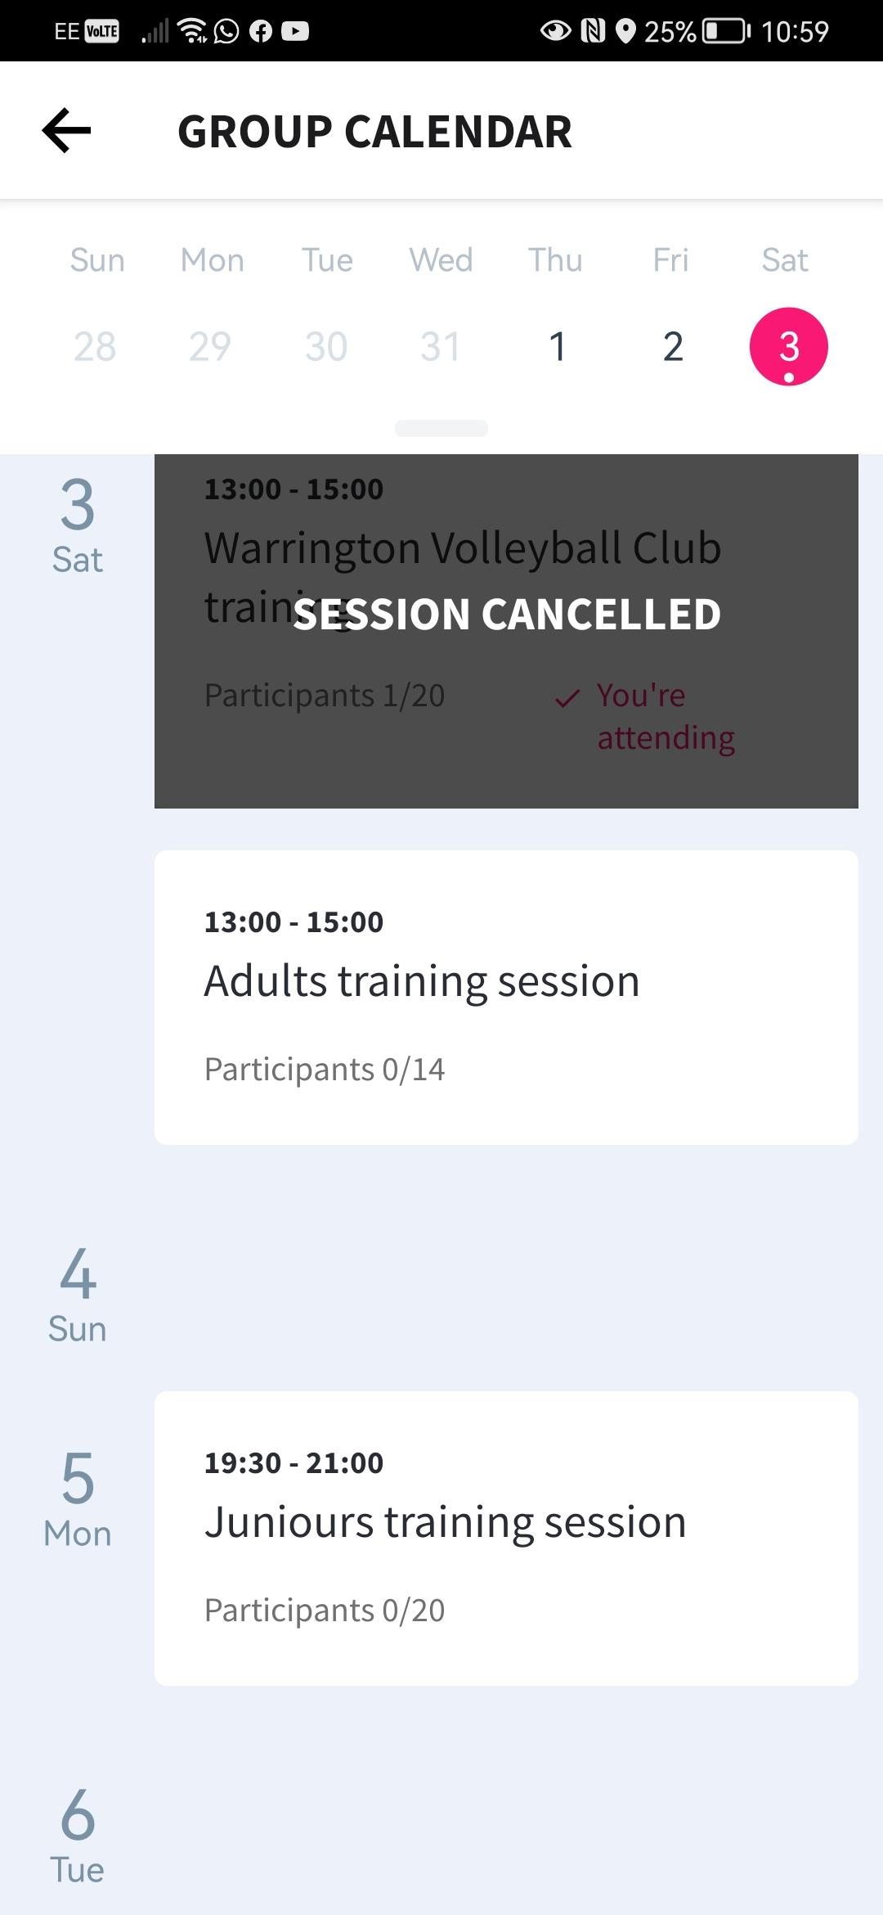

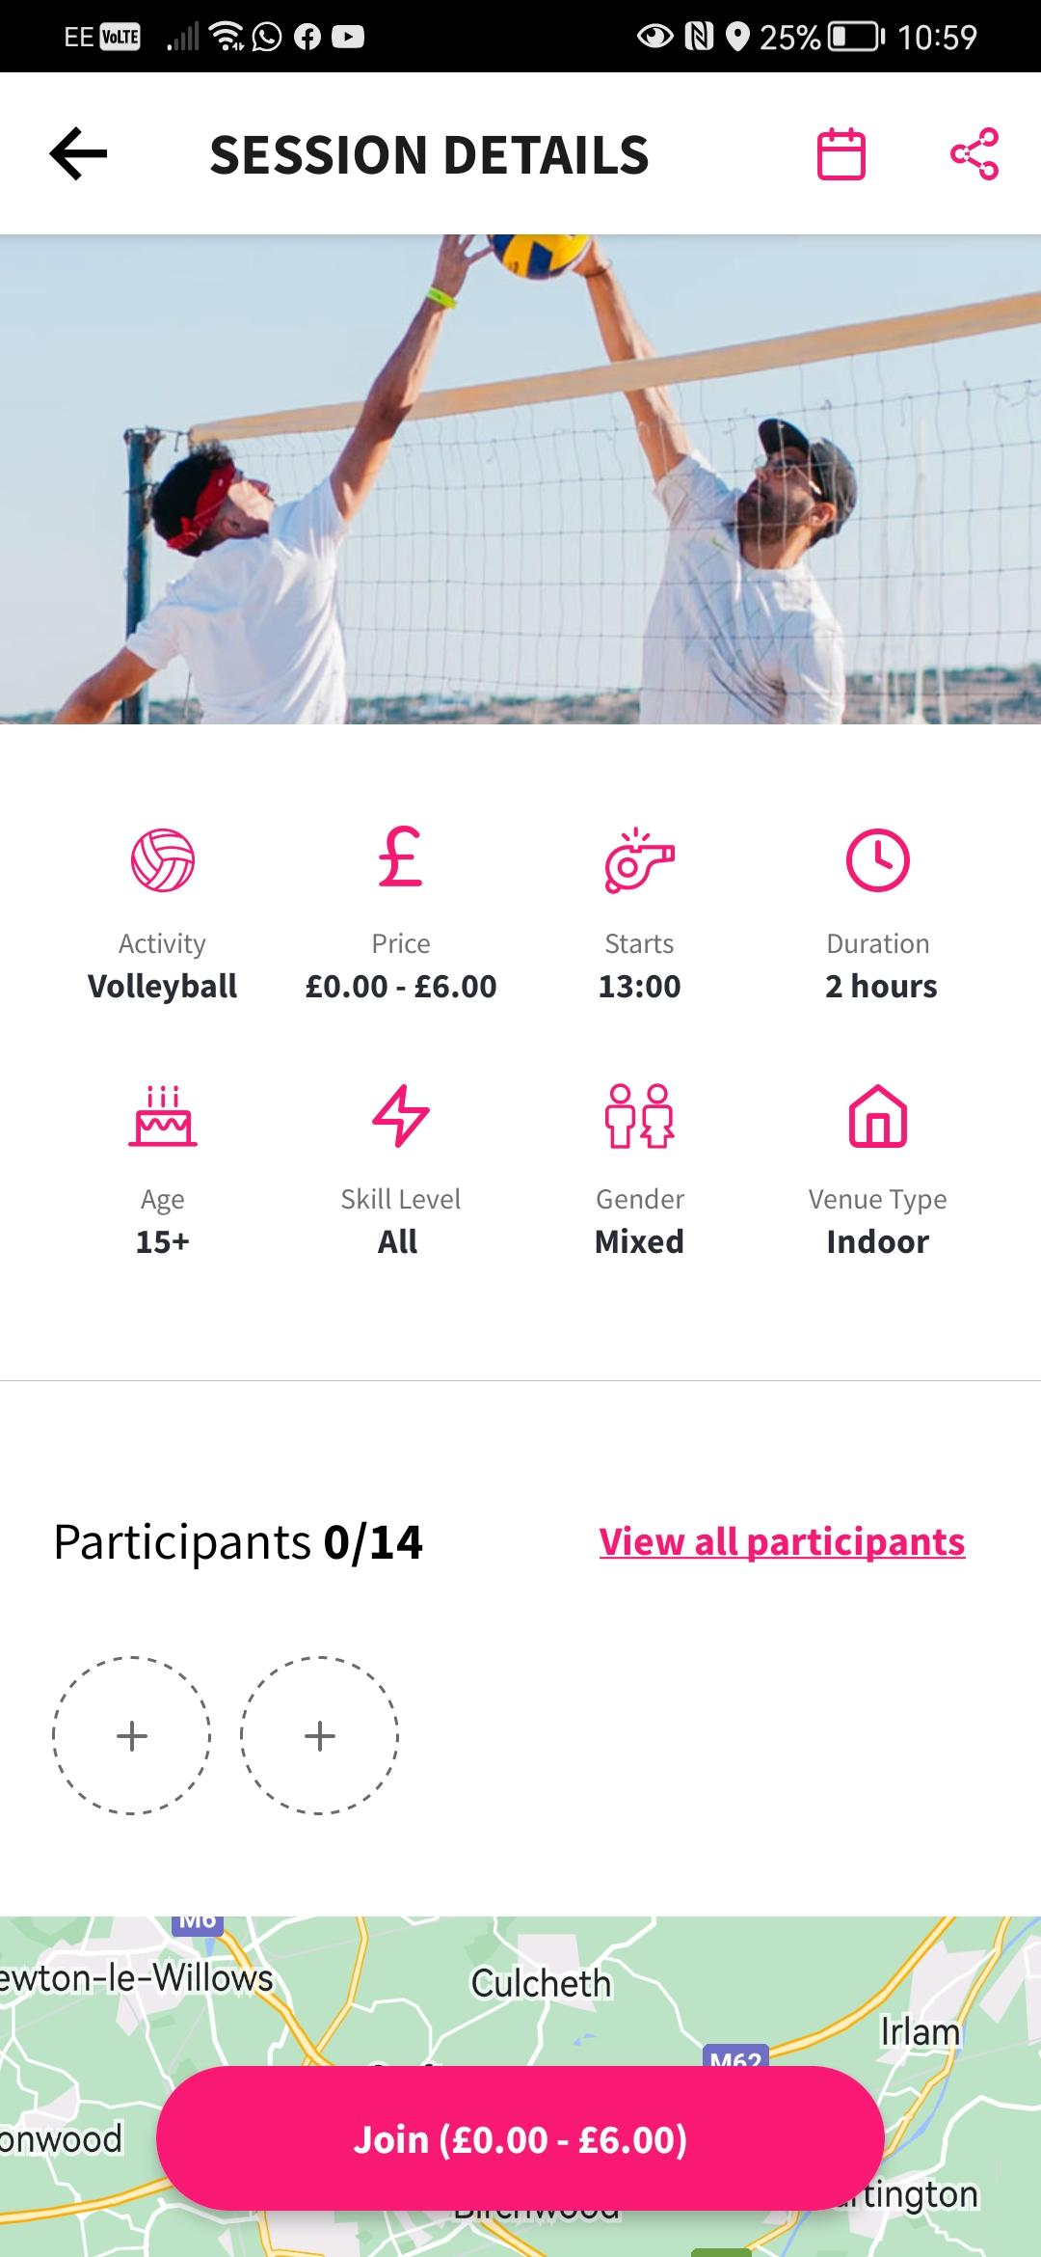

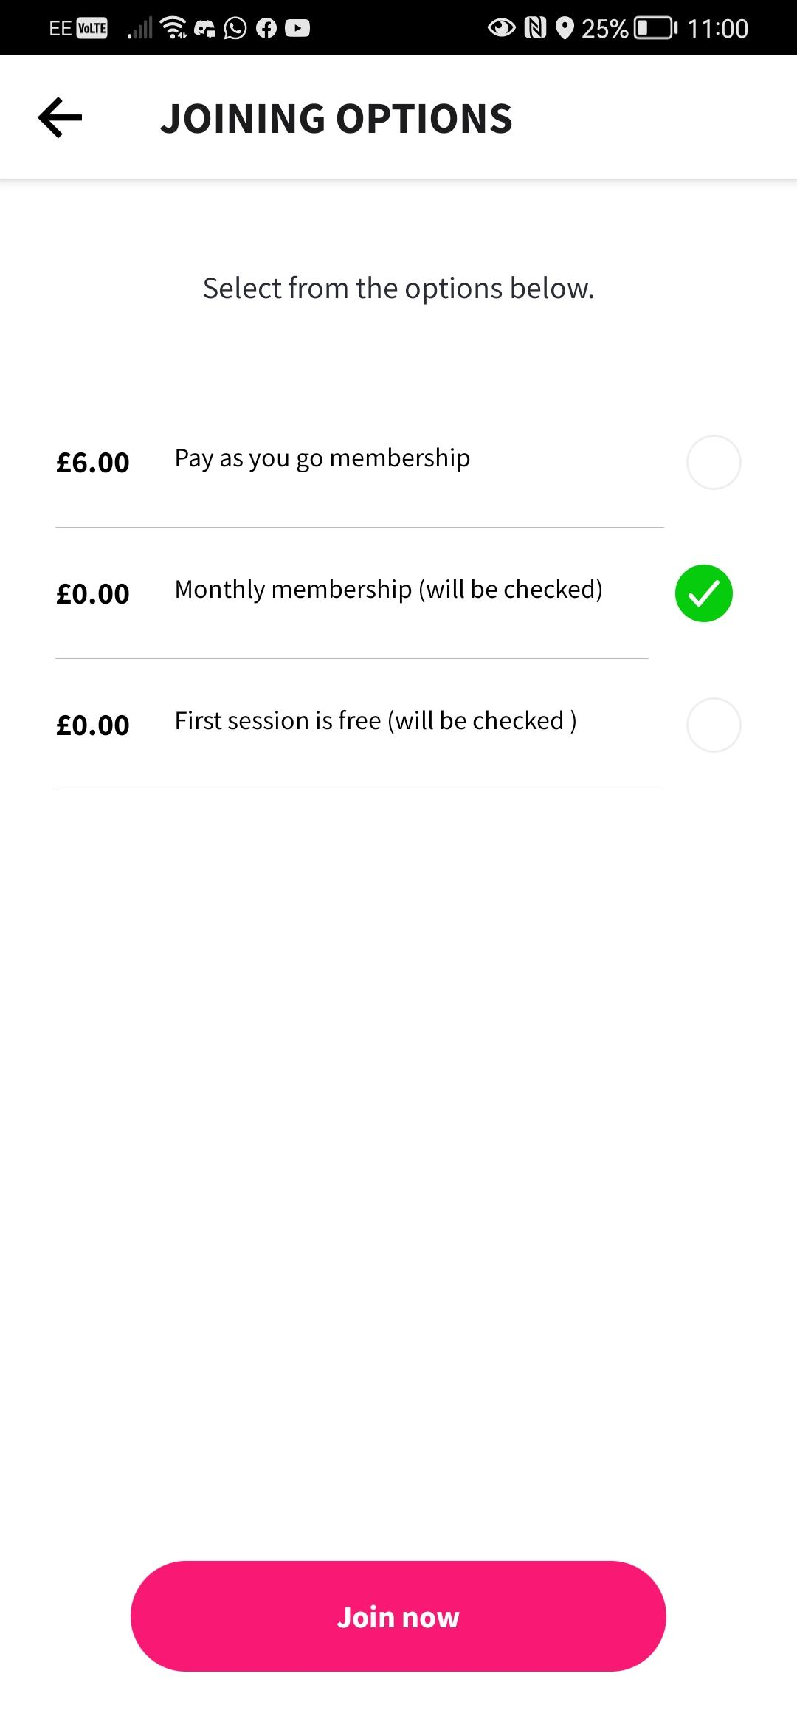

1. Another key thing to remember would be to connect your card to your account to make payment easier this step i important as it makes checking out so much easier you can do this by going to profile and then wallet and add your account details this also makes refunds in case of cancellation very easy and fast

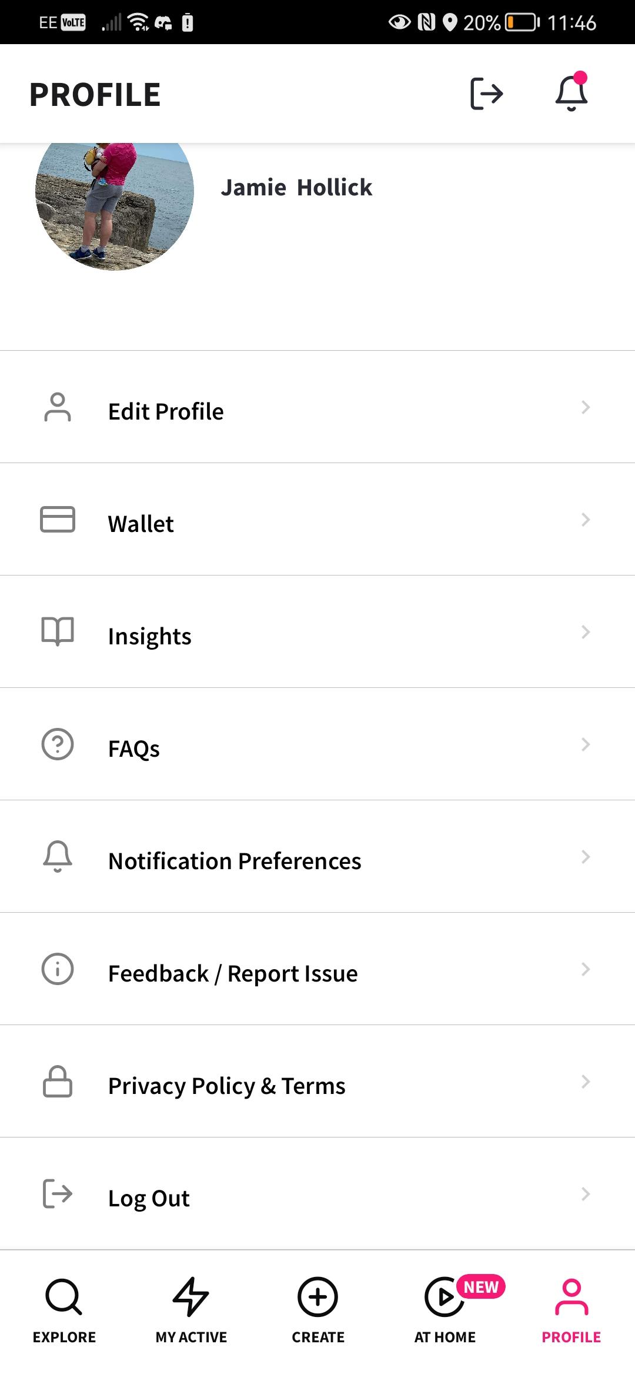

Juniours/parents

1. Download the orfiactive app on the app store link will be provided



1. Make an account (**if parent is completing form please use juniours information for the registration as they will be locked out of juniour sessions if you use your own due to age reatrictions**) follow on screen instructions make sure to verify the account via email



1. Once account has been made please use link to join the warrington volleyball group
2. To view sessions go to myactive and click on the warrington volleyball club group, then click on view group calendar





1. To join a session clicked on desired session by finding the correct date and press join session and select correct payment method







1. Another key thing to remember would be to connect your card to your account to make payment easier this step i important as it makes checking out so much easier you can do this by going to profile and then wallet and add your account details this also makes refunds in case of cancellation very easy and fast



Thanks for your time

From now on we will be using this system to book our places so if you havent booked a place for your child if your a parent or for yourself you wont be allowed in the session.

The session booking is open upto five minutes before start time we wont be accepting last minute walk ins anymore this is to help us plan sessions in a orderly fashion and to help the club go cashless as it is extra work to collect in cash.